**Setting Up Application Environment Docker Installation**

|  |  |
| --- | --- |
| Date | 24 OCT 2022 |
| Team ID | PNT2022TMID07494 |
| Project Name | Skill and Job Recommender Application |

# Step 1:

Go the official Docker website:

[***https://docs.docker.com/desktop/install/windows-install/***](https://docs.docker.com/desktop/install/windows-install/)

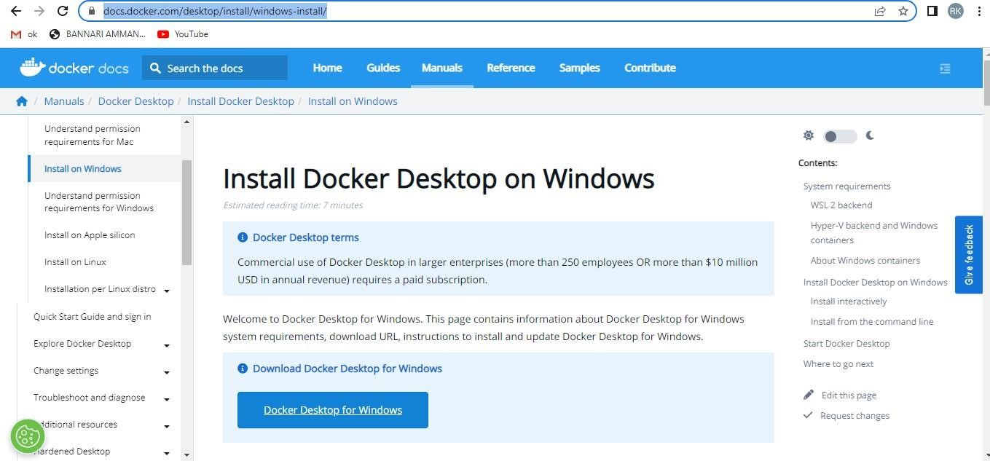

# Step 2:

Click that button (Docker Desktop for Windows) and download will start and it takes a few minutes to complete.

# Step 3:

Go to downloads in browser (or) type **ctrl + J**, it will navigate to the download page and double-click the particular docker file.

While Installing it will take some time to complete the installation.

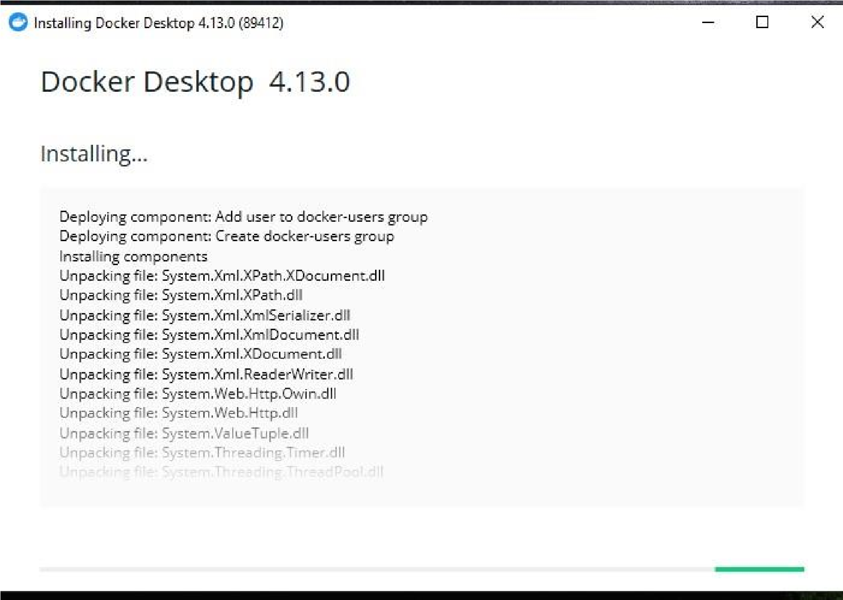

After that , Installation is complete. This icon was added to your desktop. Double-click the icon to start the docker app, you can register and login that app to access those credentials.

Docker will start correctly, the left bottom side was shown in green color,

docker

will

show

the

status

of

docker

app

working

successfully.

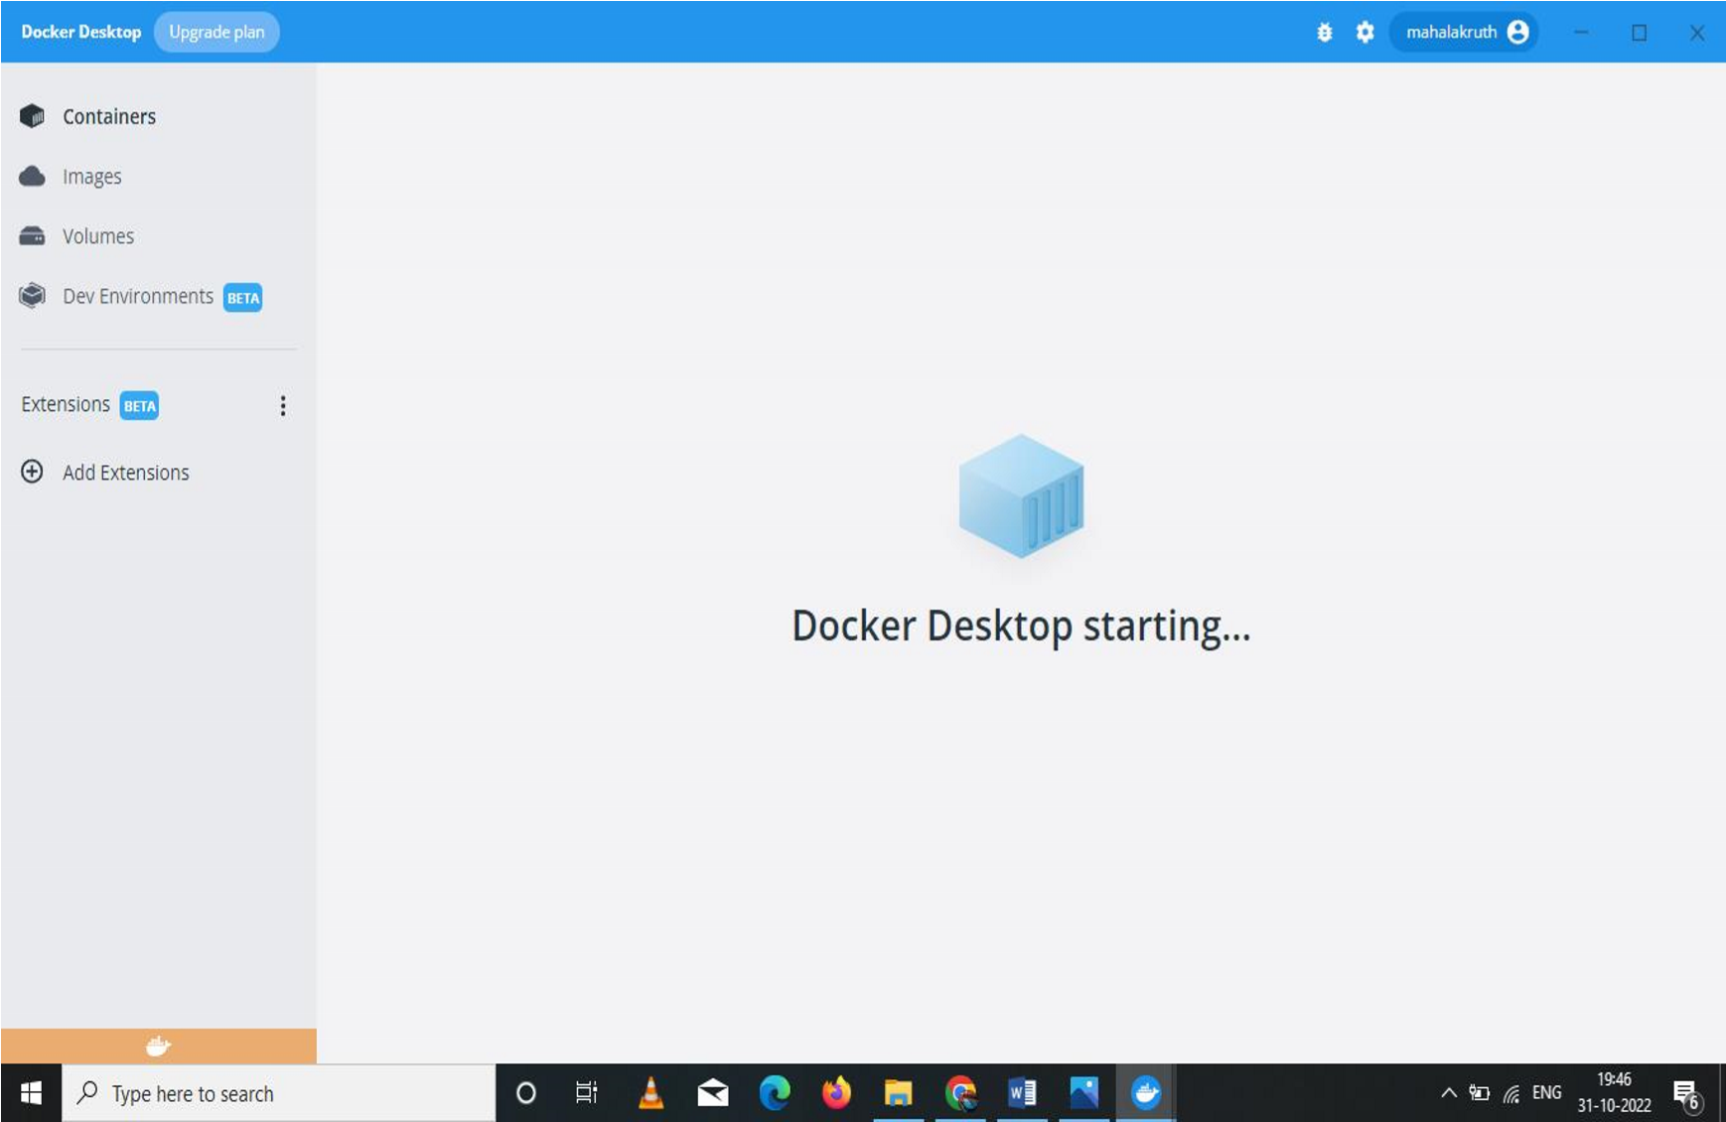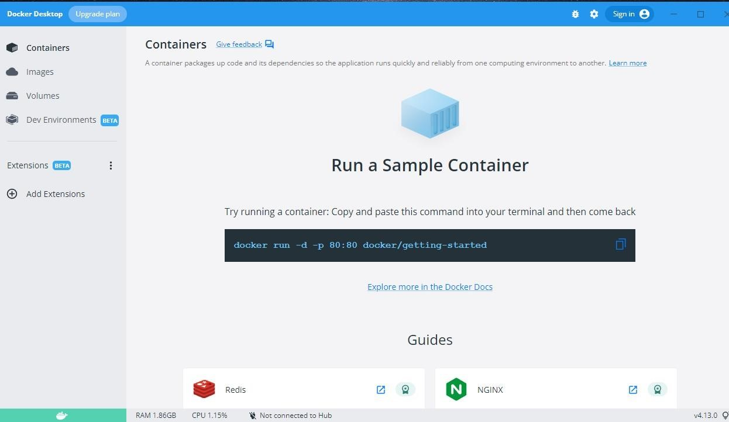

# Step 6:

Finally, the docker is installed successfully.

